Final Project Part 2
Part 1: Integrating Data from an API
The support-ticket API is provided as a local mock server. Start it with python3 mock_api.py, then read from http://127.0.0.1:8000/v1/tickets?page=1.
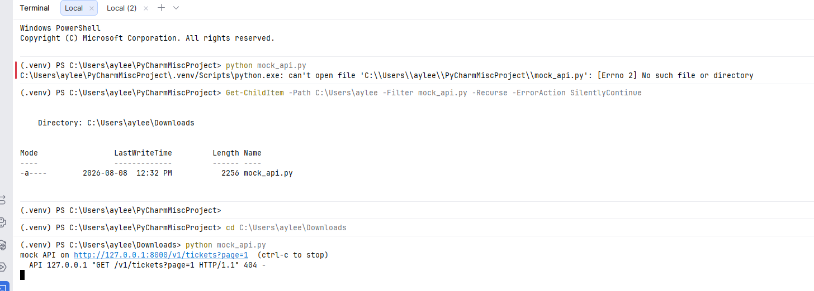
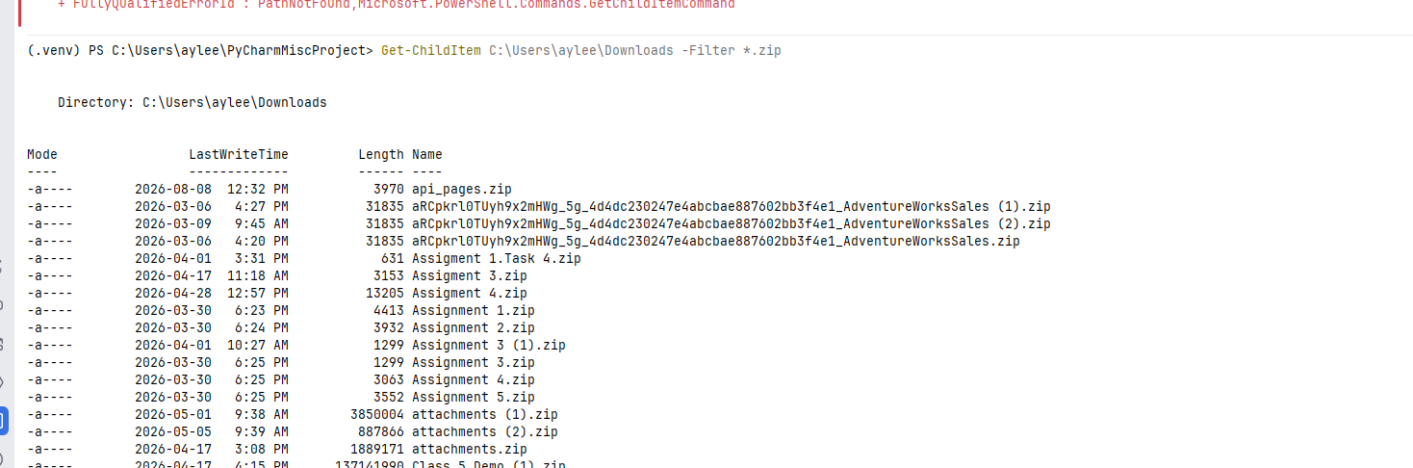
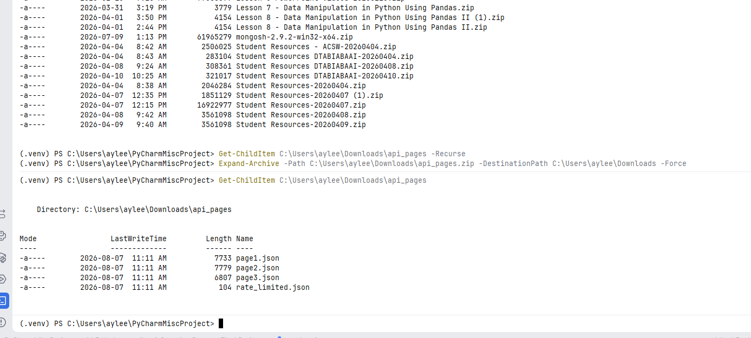
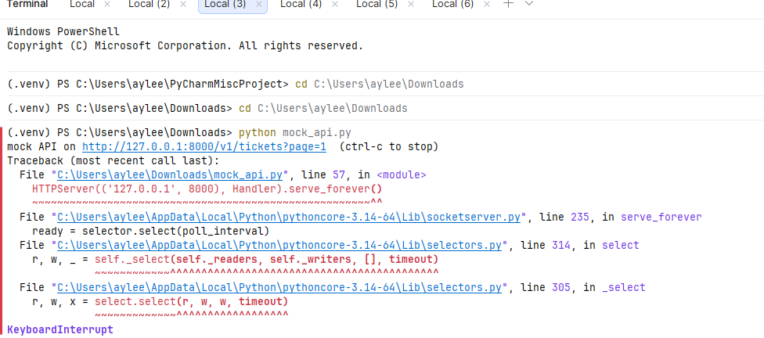
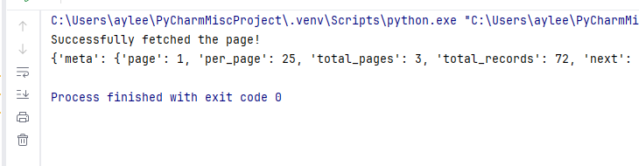

- Fetch every ticket. The API returns 25 per page and tells you in meta.next where the next page is. Follow that field rather than hard-coding the number of pages; a feed that grows next week should not need a code change.
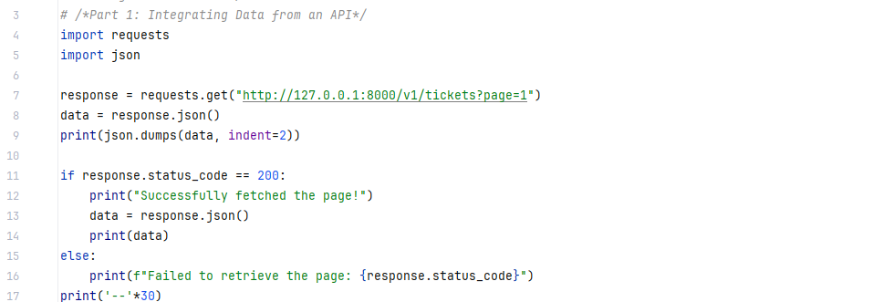
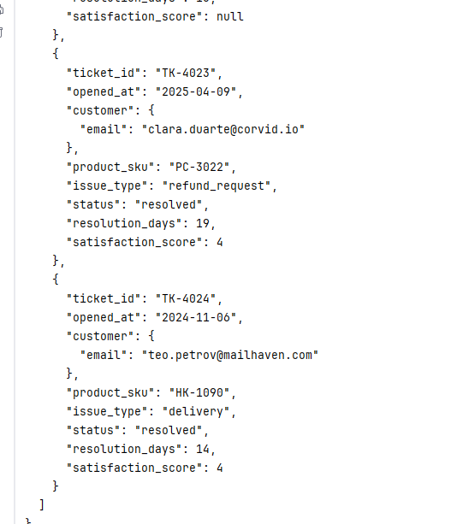

- Handle the rate limit. One request will come back with HTTP 429 and a Retry-After header instead of data. Wait and retry rather than crashing or skipping the page. A run that quietly loses 25 tickets is worse than one that fails loudly.
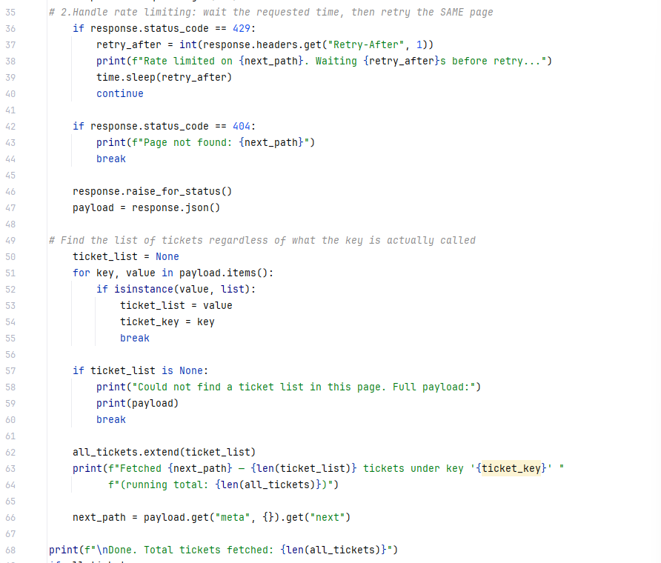
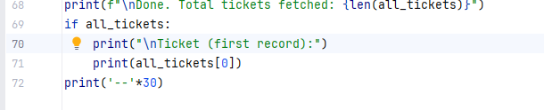
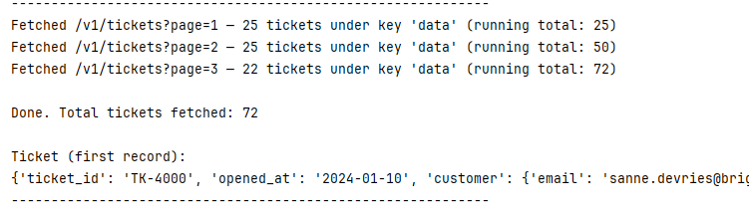
- Handle the optional fields. Open tickets have no resolution_days, and only resolved tickets carry a satisfaction_score. Decide what goes in the database for a value that does not exist yet, and say why that is different from a value of zero.
- 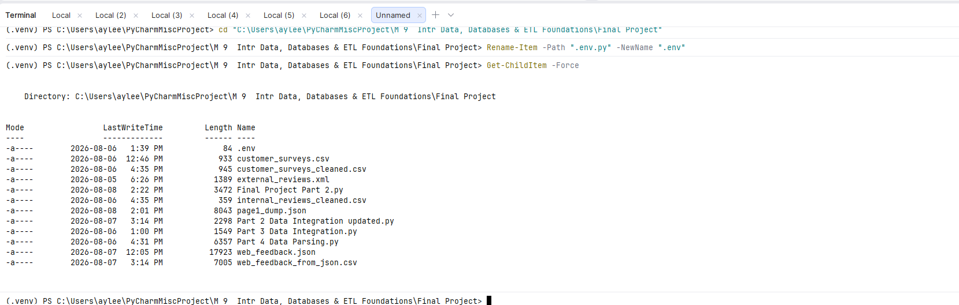
- Load into a staging table, then into a permanent support_ticket table in your Project 1 database. Match each ticket to an existing customer by email and product by SKU, using the same approach you already built.
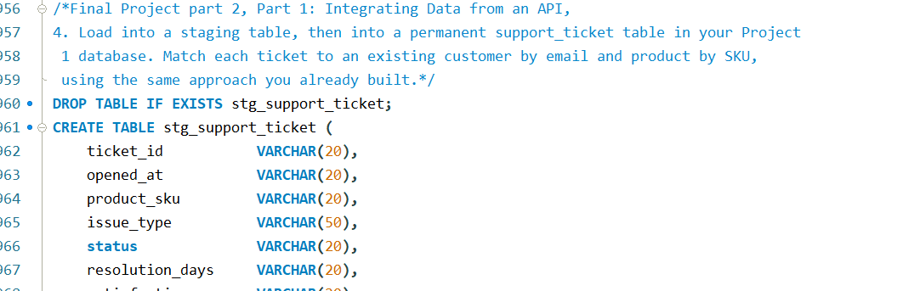
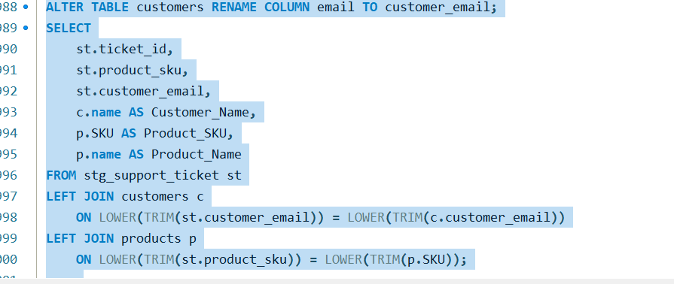
- Compare the API to the file sources in a short paragraph: what was harder about it, and what would break if the API were unavailable when your load ran.
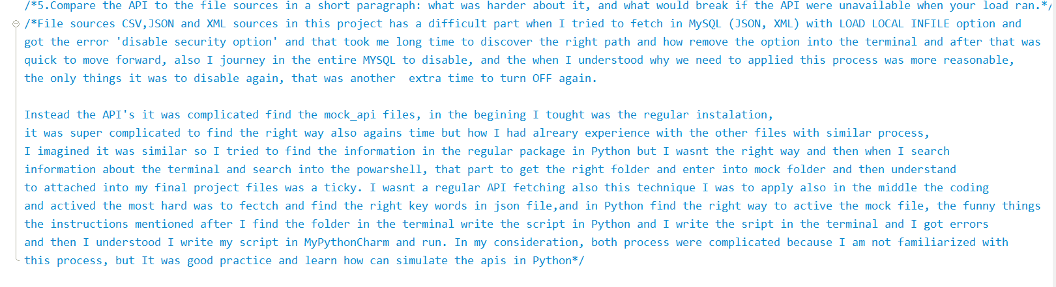
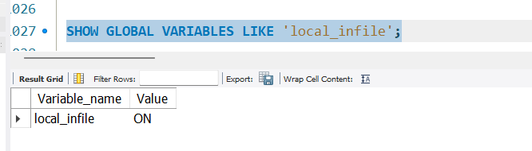
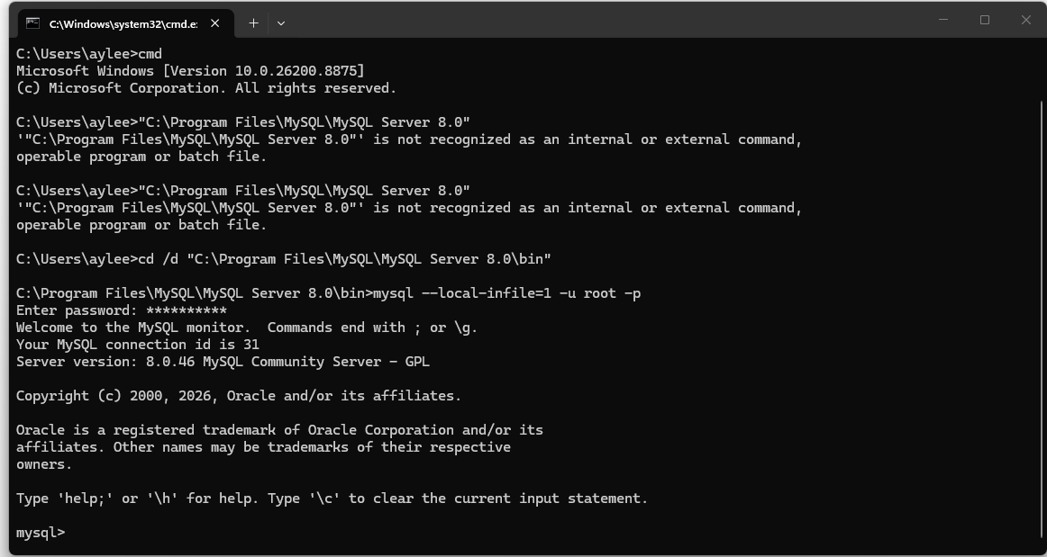
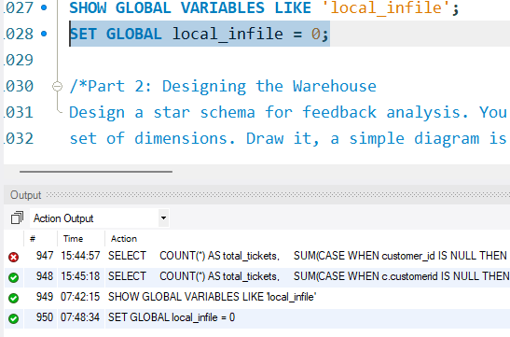
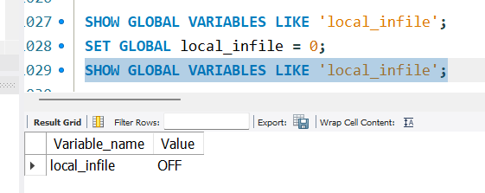
Part 2: Designing the Warehouse
- Design a star schema for feedback analysis. You need one fact table and a set of dimensions. Draw it, a simple diagram is fine; it does not need to be a full ER diagram.
Entire view of Data Warehouse include all fact and dimensions.
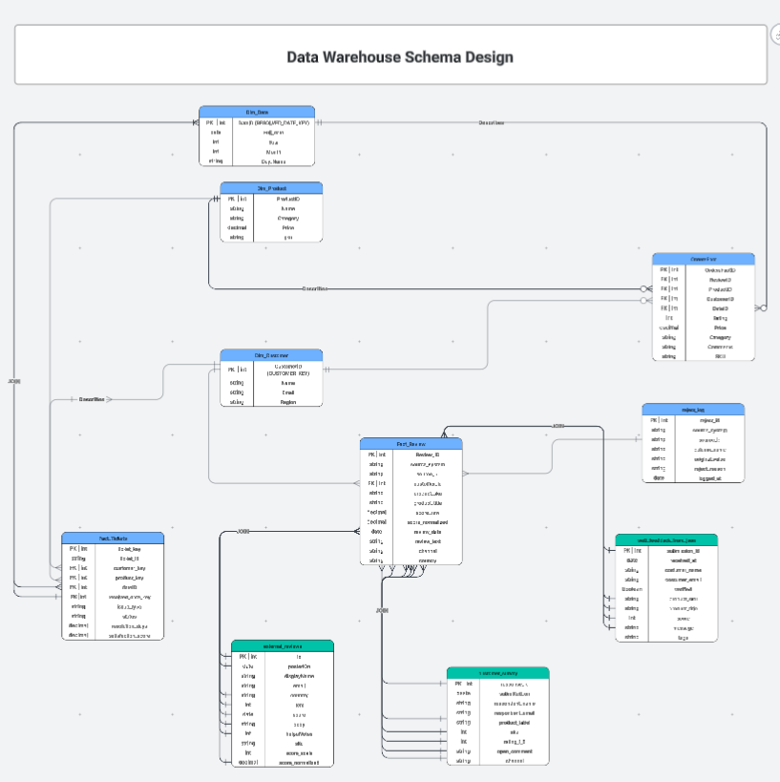
Data Warehouse include fact_review and dimensions
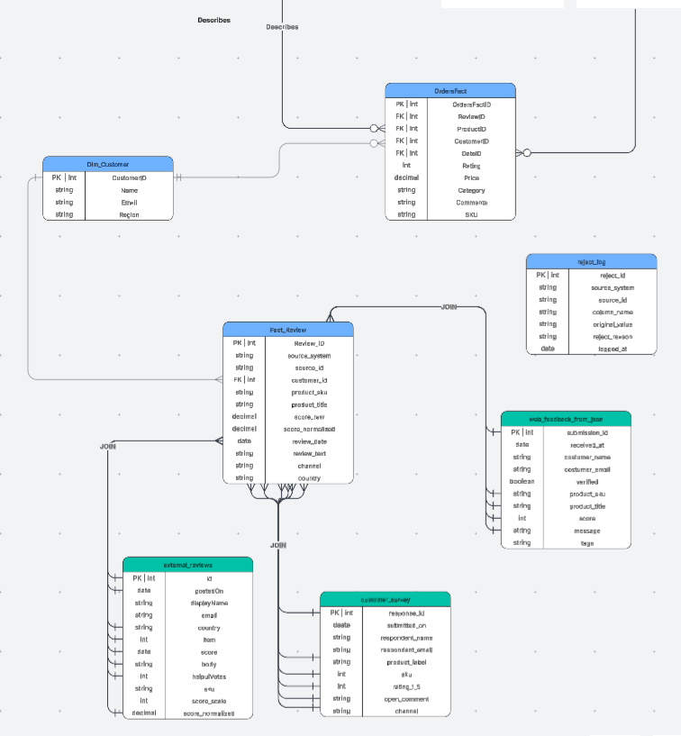
- State the grain of your fact table in one sentence: what does exactly one row represent? Get this wrong, and every number the warehouse produces will be wrong in the same way.
OrdersFact represents a combination of 3 dimensions, dim_customer, dim_product and dim_date
Fact_Review represents and get information from dim_customer, and combined 3 differents tables with differents informations and from differets sources: external_reviews_from _xml, web_feedback_from_json and customer_survey_from_csv. The Fact table contain 132 rows, we can retrieve enough information from those tables.
Fact_tickets represents all dim_product, dim_customer, and dim_date focuses it shows the ticket information.
- Build a date dimension covering the range of your data, including year, quarter, month, month name, and day of the week. Generate it with SQL rather than typing it.
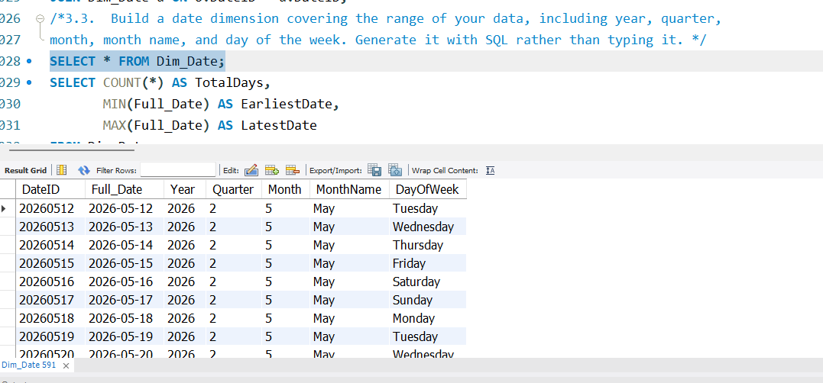
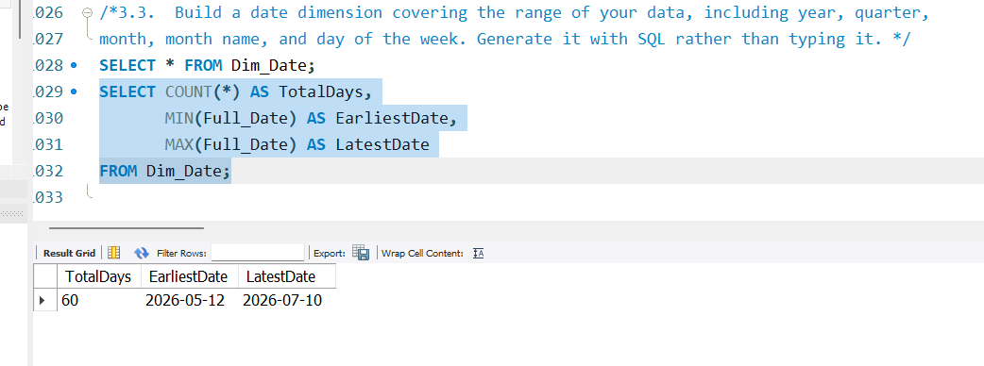
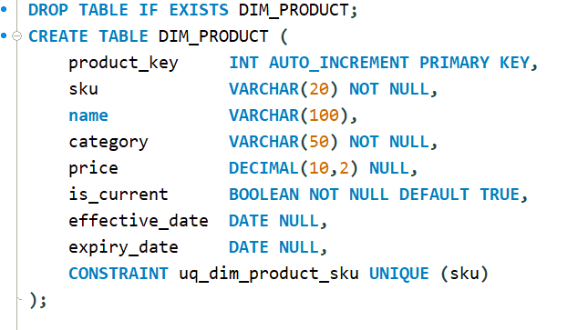
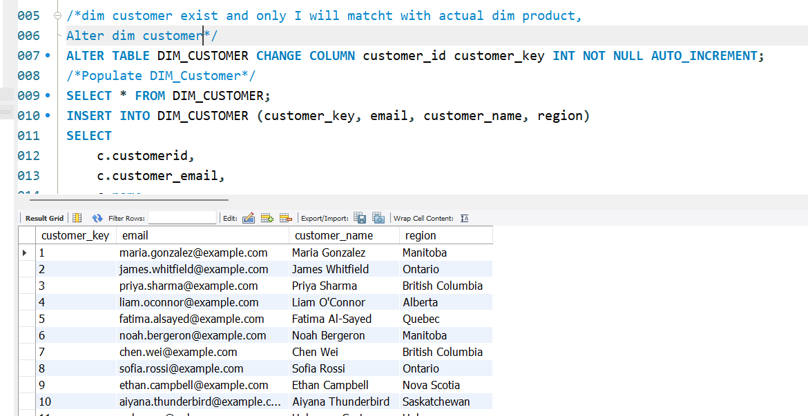
- Use surrogate keys in the warehouse rather than reusing operational IDs, and explain in one paragraph why a warehouse normally does so.
- Add tickets as a second fact table that shares the same product, customer, and date dimensions. Dimensions used by more than one fact table are called conformed; say what would go wrong if each fact table had its own copy of the product dimension instead.
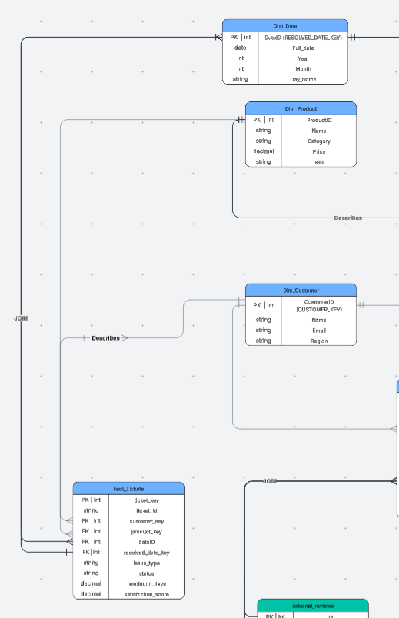
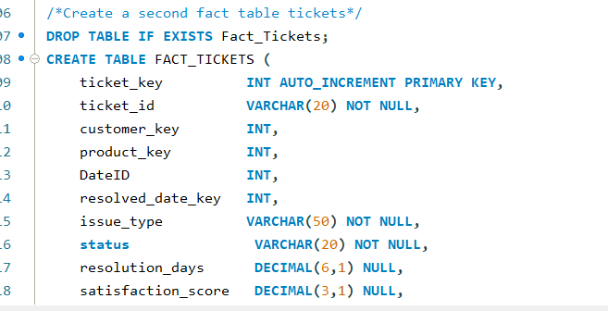
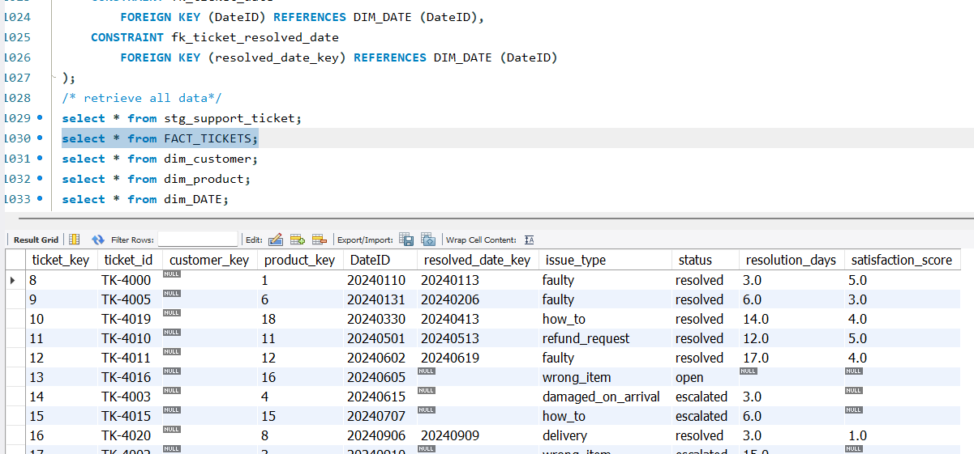
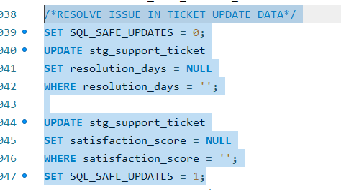
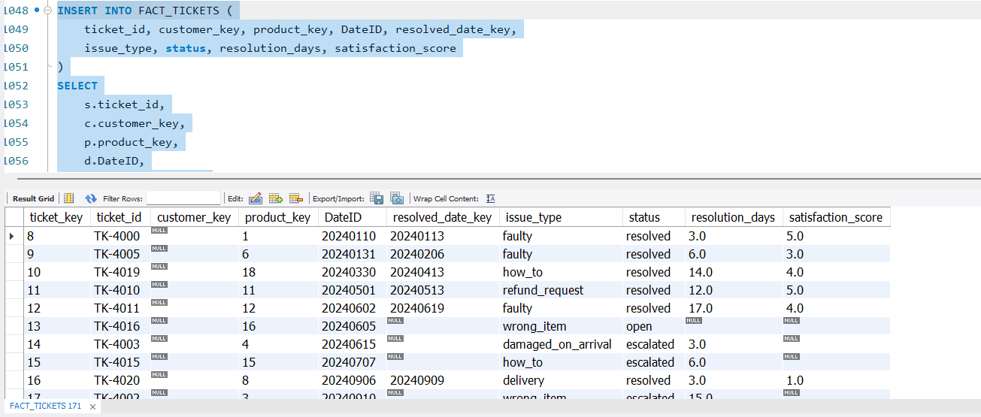

- Compare the two schemas. Take one analytical question, write it against your Project 1 normalized schema and against your star schema, and show both queries side by side. Count the joins in each.
Boths schema provide the same result in this case.
What is the average rating by product category, per quarter?
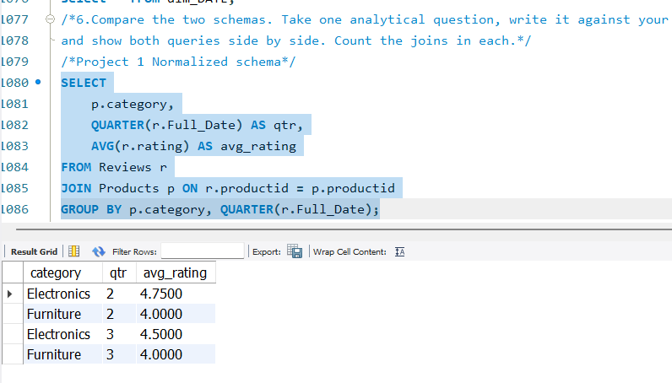
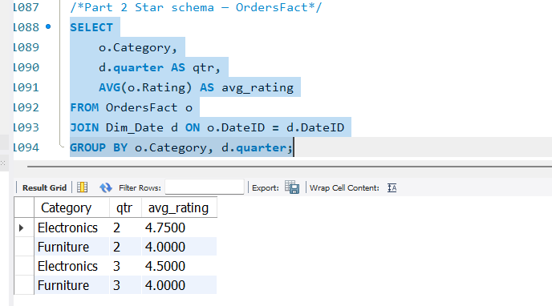

Part 3: Building the ETL
- Load in dependency order: dimensions first, then facts, because a fact row cannot reference a dimension key that does not exist yet. Write this as a repeatable script.
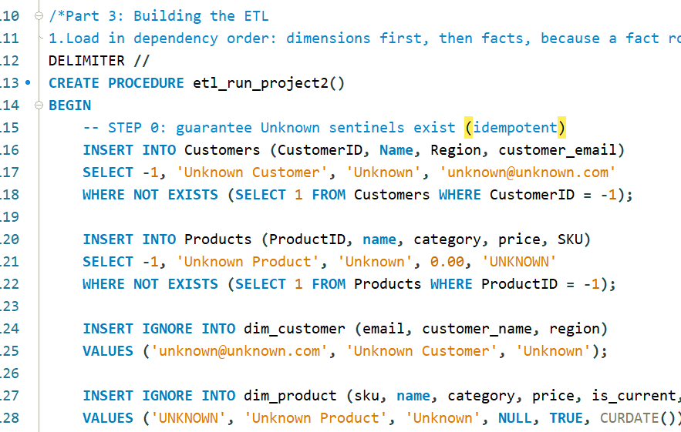
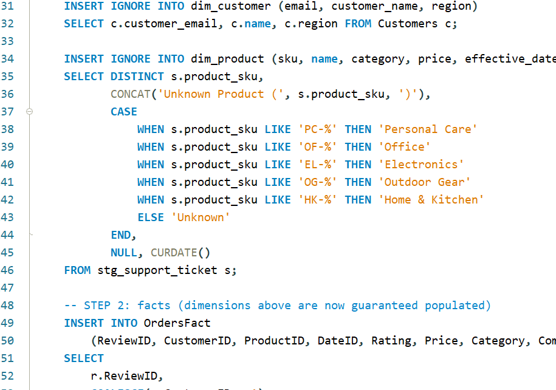
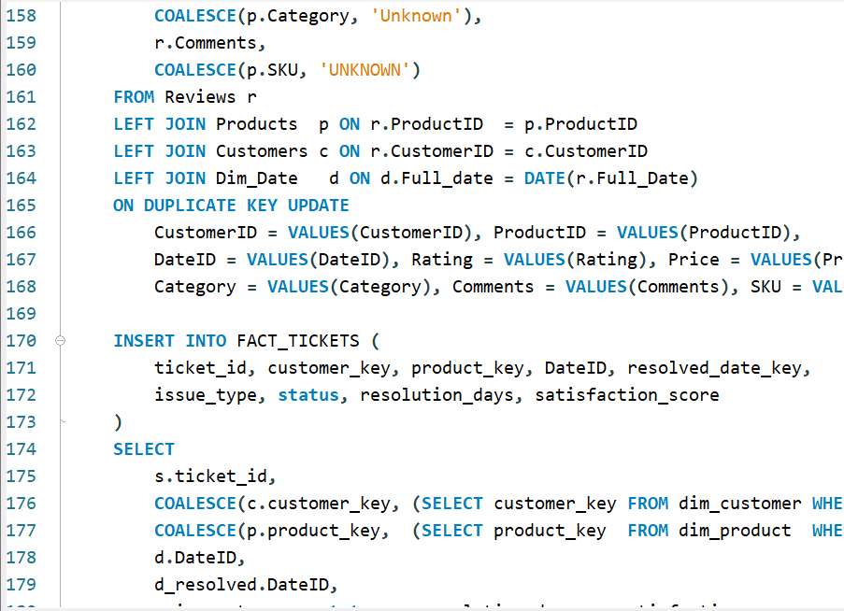
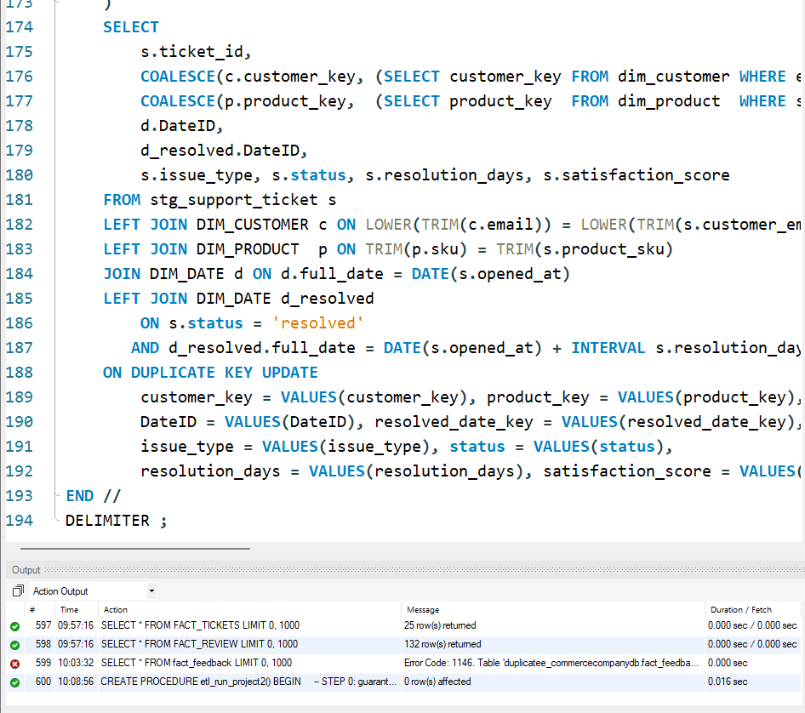
- Handle unmatched rows. Project 1 left 12 reviews with no customer. A fact table cannot hold a NULL foreign key to a dimension, so add an "Unknown" member to the customer dimension and point those rows at it. Explain why this is better than dropping them.
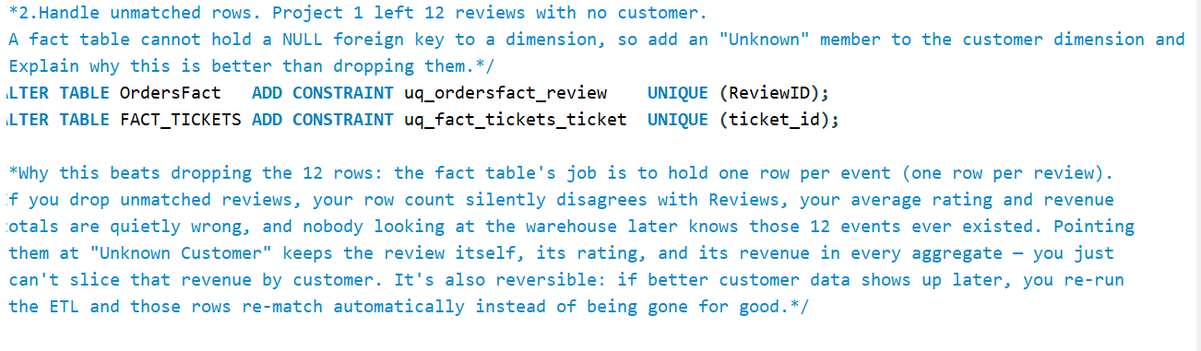
- Reconcile after loading. Prove the warehouse agrees with the source by comparing the fact row count against the review count, and total revenue or average rating against the operational figure. A warehouse nobody has reconciled is a warehouse nobody should trust.
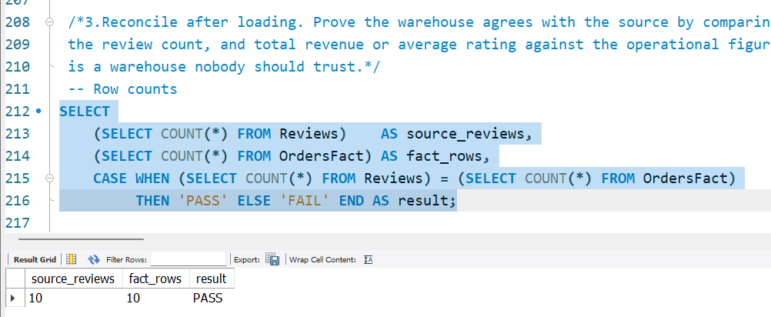
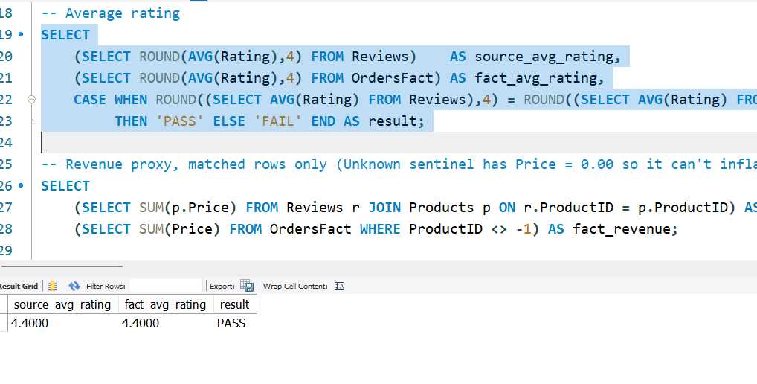
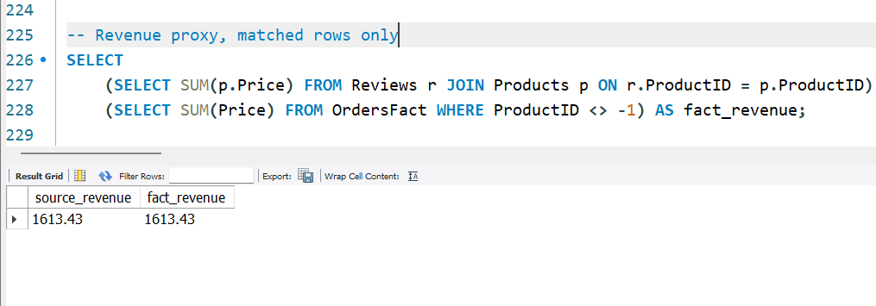
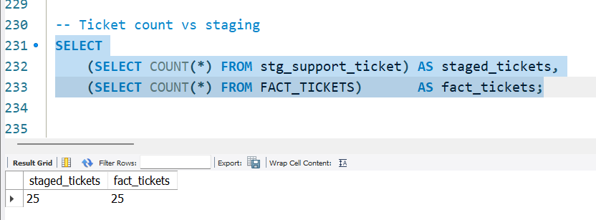
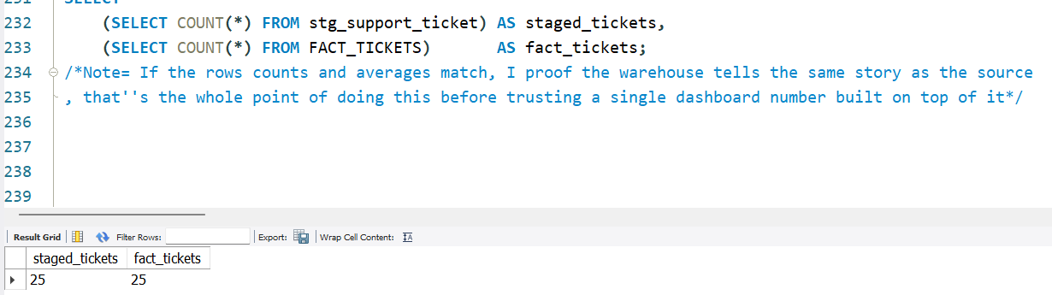
- Make it re-runnable. Running your ETL twice must not double the fact table. Show the row count before and after a second run.
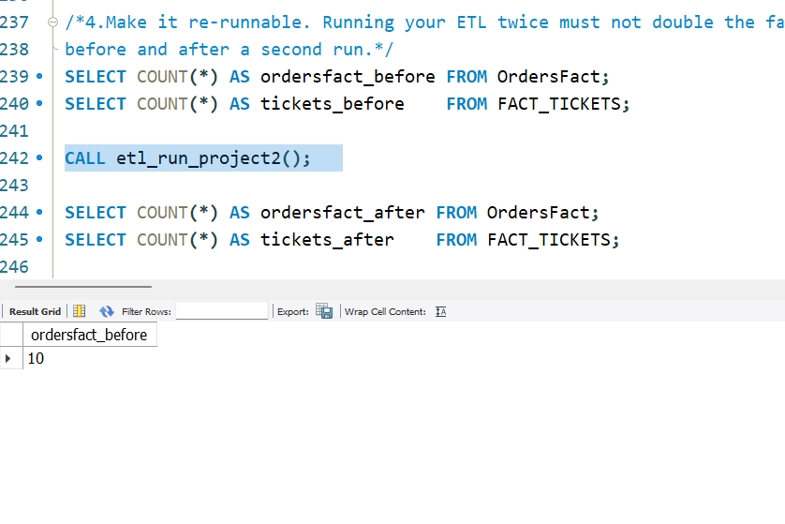
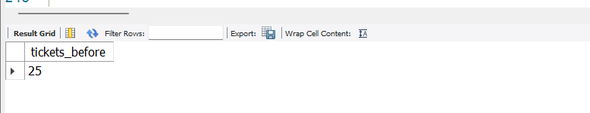
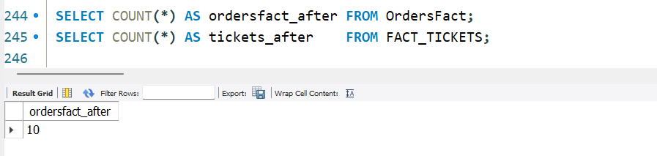
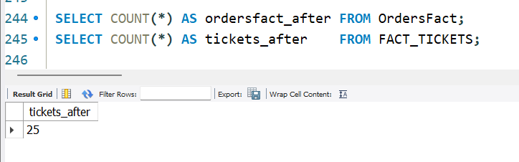
- Describe your pipeline as ETL or ELT, and say which stage does the transforming and why you put it there.
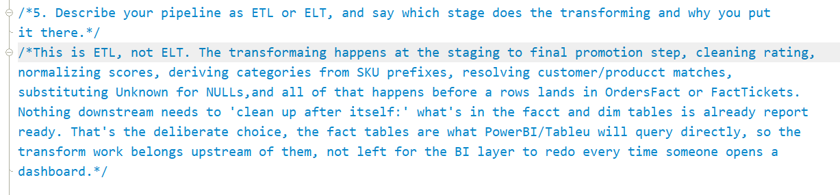
- Written answers — one page is enough. Number them to match the task
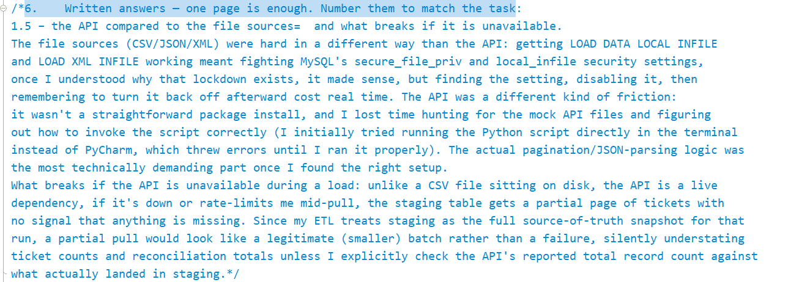
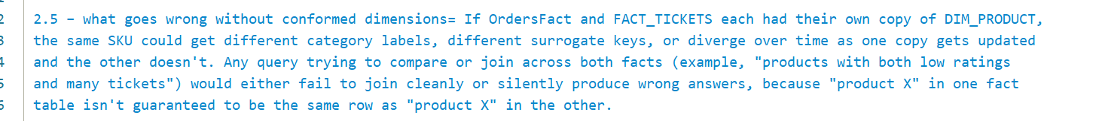
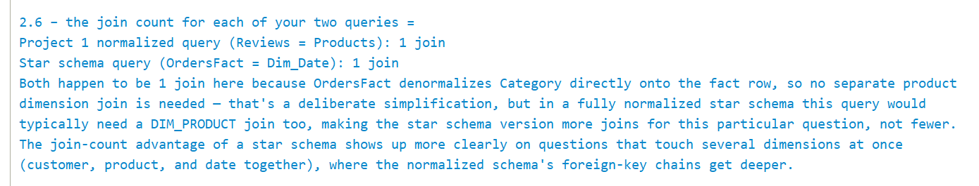
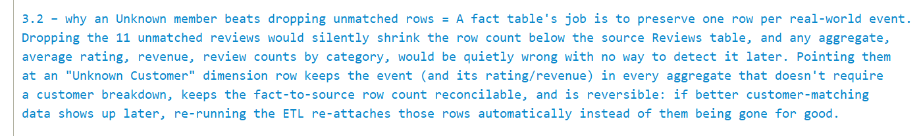
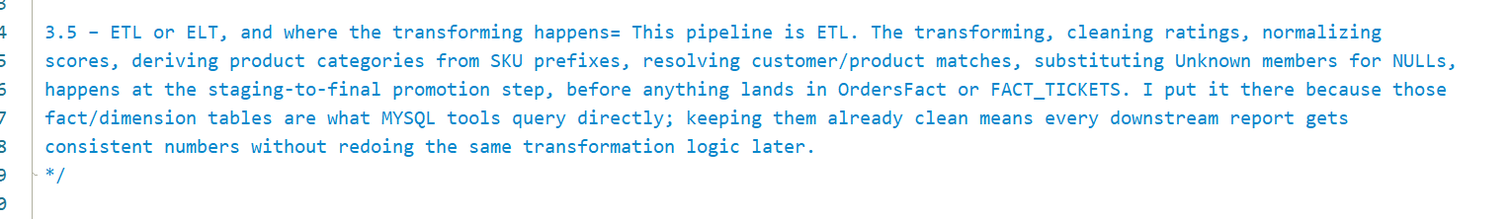
Deliverables
One archive, lastname_firstname_project2.zip:
- API script — the code that fetches and loads the tickets, with the pagination and retry logic visible.
- Star schema diagram — fact and dimension tables with their relationships. Hand-drawn is acceptable if legible.
- SQL scripts — warehouse tables, the ETL that fills them, your reconciliation checks, and the two side-by-side queries from Part 2.6.
- Written answers — one page is enough. Number them to match the task:
  - 1.5 – the API compared to the file sources, and what breaks if it is unavailable.
  - 2.2 – your grain statement, in one sentence.
  - 2.4 – why a warehouse uses surrogate keys.
  - 2.5 – what goes wrong without conformed dimensions.
  - 2.6 – the join count for each of your two queries.
  - 3.2 – why an Unknown member beats dropping unmatched rows.
  - 3.5 – ETL or ELT, and where the transforming happens.
Files
- mock_api.py — the local API server. Needs Python 3.9+ and nothing else. Start it before you run your fetch script.
- api_pages/ — the same responses saved as files. Use these only if you cannot run the server; note it if you did, because pagination and retry still have to be demonstrated.

